STUDENTS’ MULTIPLE INTELLIGENCE IN LEARNING SPEAKING
B087/S1/STKIP/-SLW/VIII/2017
(A case study at one of senior high school in Cimahi)

A RESEARCH PAPER

Submitted to English Education Study Program of STKIP Siliwangi Bandung
in Partial Fulfillment of Requirements
for Sarjana Pendidikan Degree

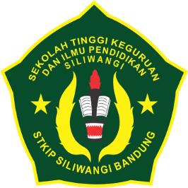

By:
ANGGY KANIA DEWY NURUL FATIMAH
NPM.13220167

ENGLISH EDUCATION STUDY PROGRAM
LANGUAGE AND ARTS DEPARTMENT
SEKOLAH TINGGI KEGURUAN DAN ILMU PENDIDIKAN
(STKIP) SILIWANGI BANDUNG
2017

